Banca dItalia Circular 285-2013 Compliance for Log360
Tagline: Fulfill Banca d'Italia's provisions with centralized security monitoring from Log360.

Overview
The Banca d'Italia Circular 285/2013 Compliance extension for Log360 enables Italian banks and credit institutions to meet the ICT governance, security monitoring, and incident management requirements within Banca d'Italia's prudential supervisory framework.
Log360 collects and correlates logs from core banking systems, cloud environments, network infrastructure, and identity platforms, providing compliance and security teams with continuous visibility into IT risk events. Teams can detect anomalies, investigate incidents, and generate audit-grade documentation for Banca d'Italia inspections and EBA supervisory reporting.

Key Features
- Generate predefined audit reports covering Circular 285/2013 ICT requirements including access management, system monitoring, and security incident detection.
- Track privileged user activities, system configuration changes, and access to core banking infrastructure in real time.
- Centralize log data from across your infrastructure to maintain real-time visibility into user activity and access patterns, supporting proactive threat identification and compliance posture.
- Export compliance evidence in PDF and CSV formats for Banca d'Italia supervisory examinations and internal ICT risk governance.
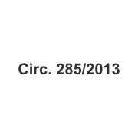


Screenshots
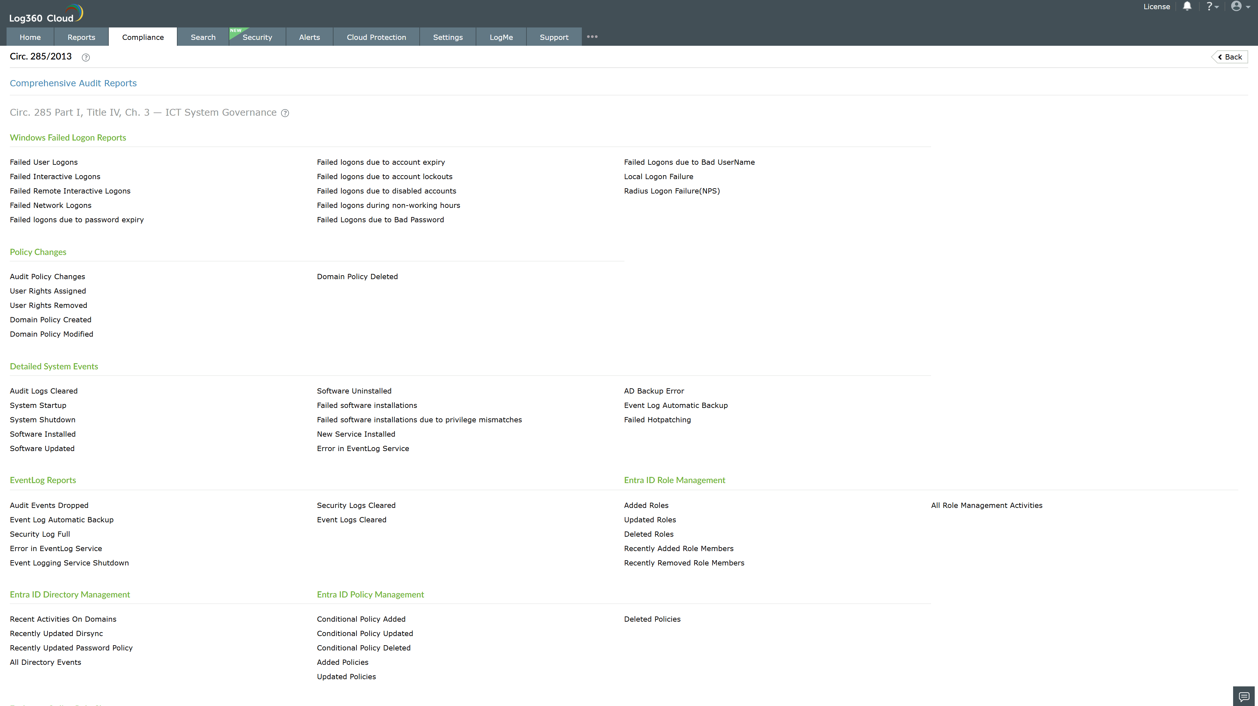
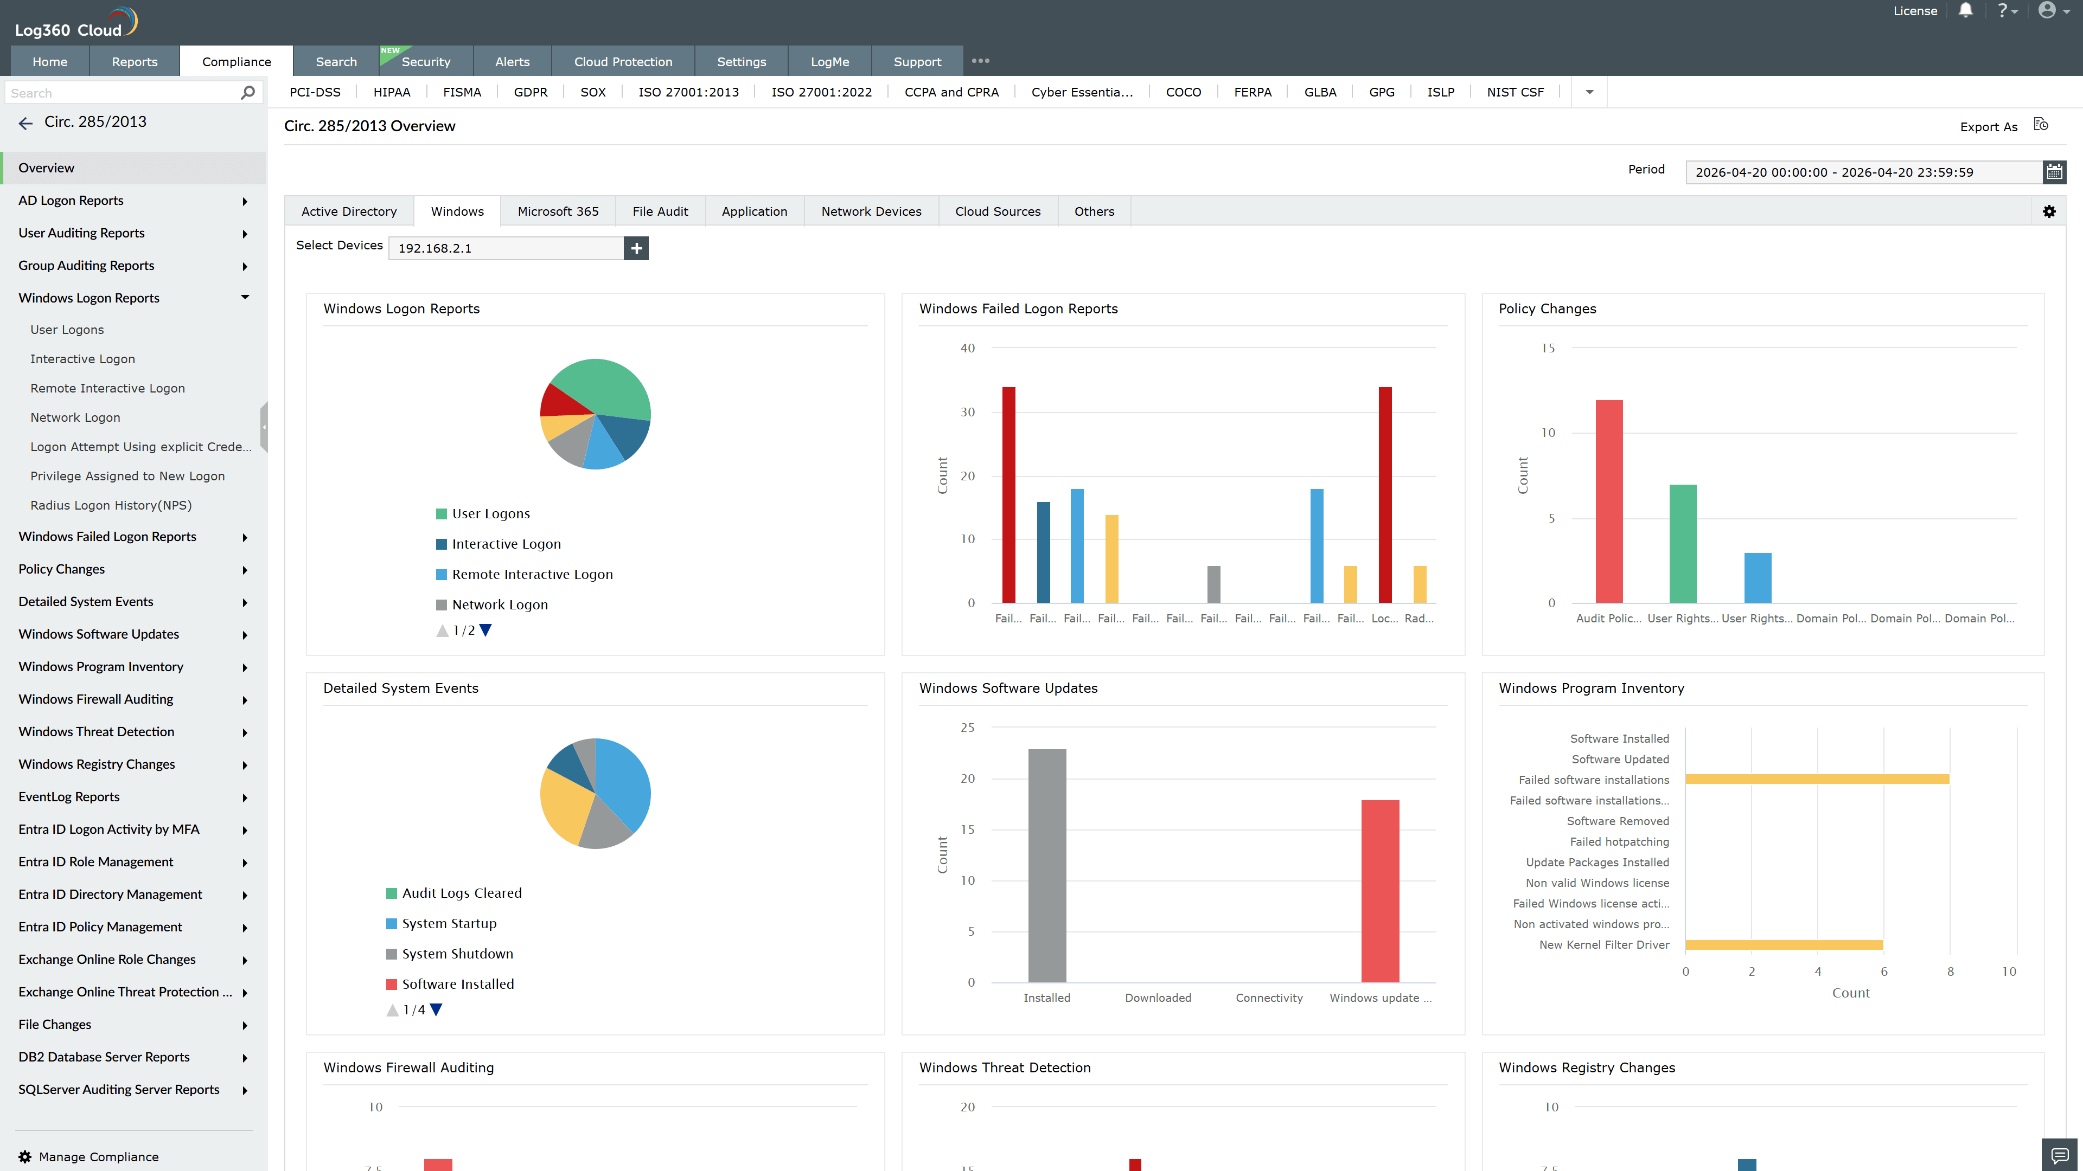
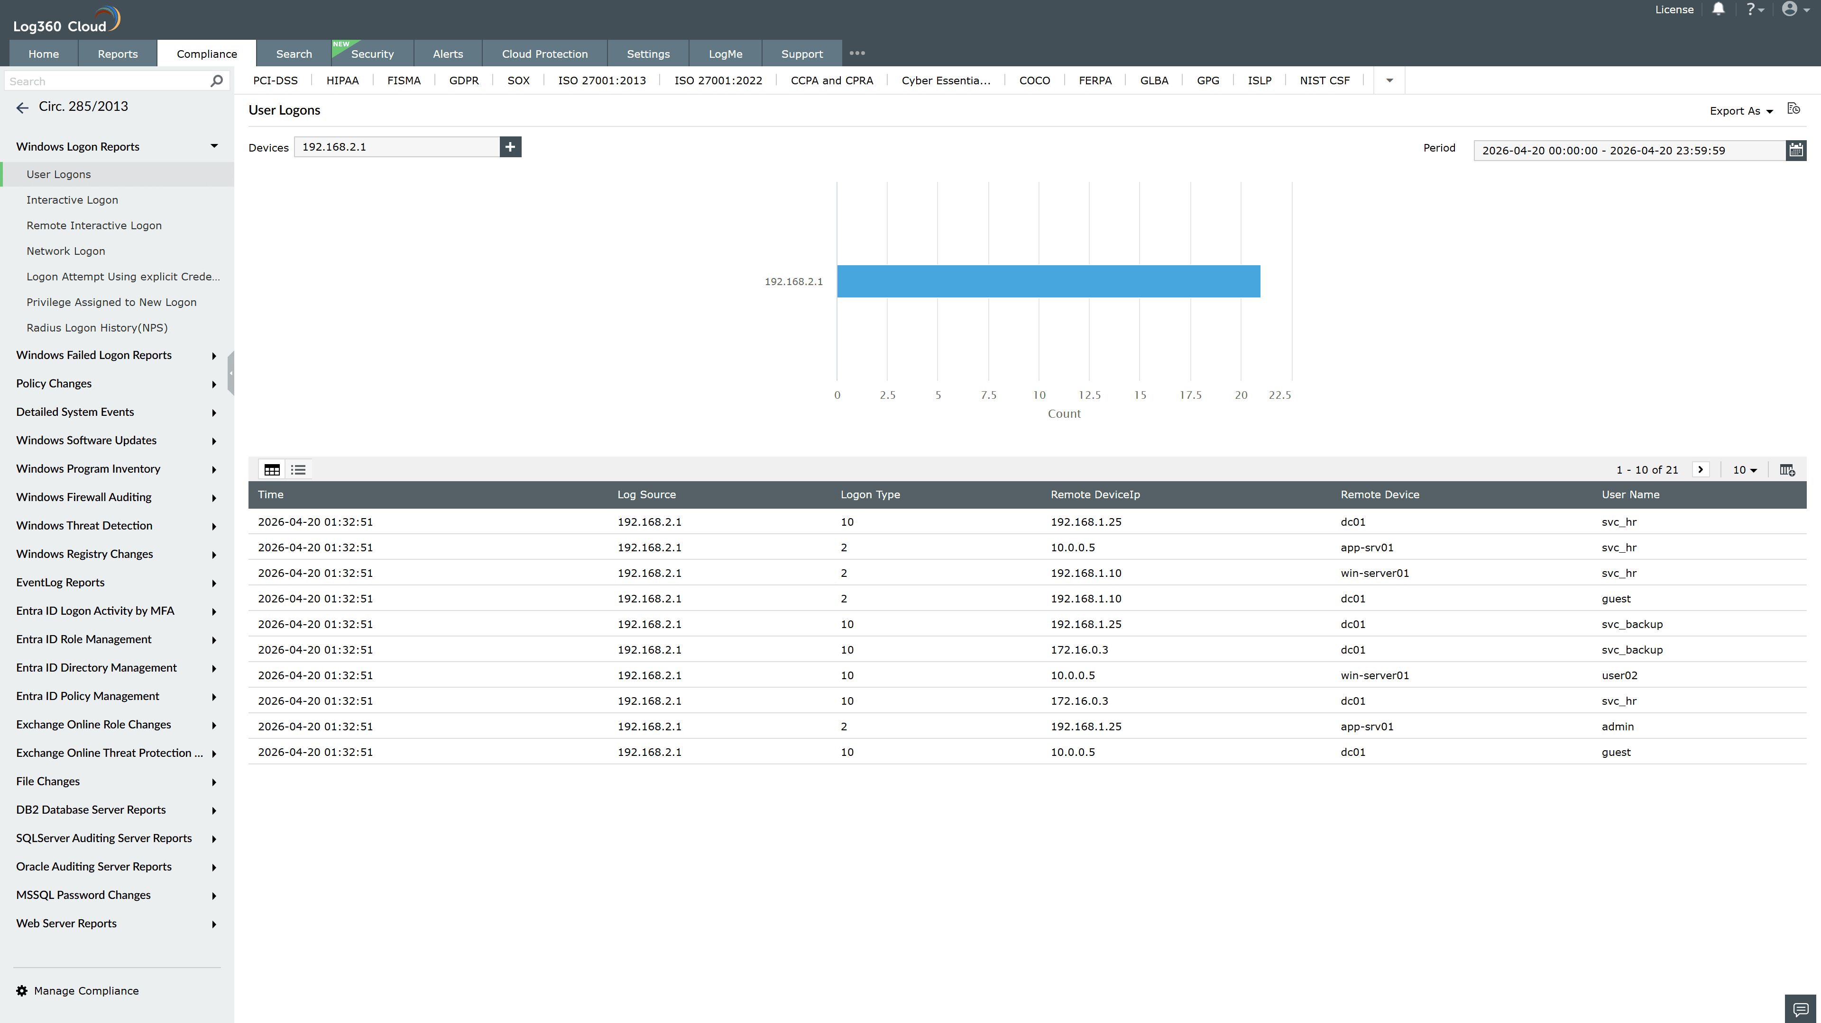
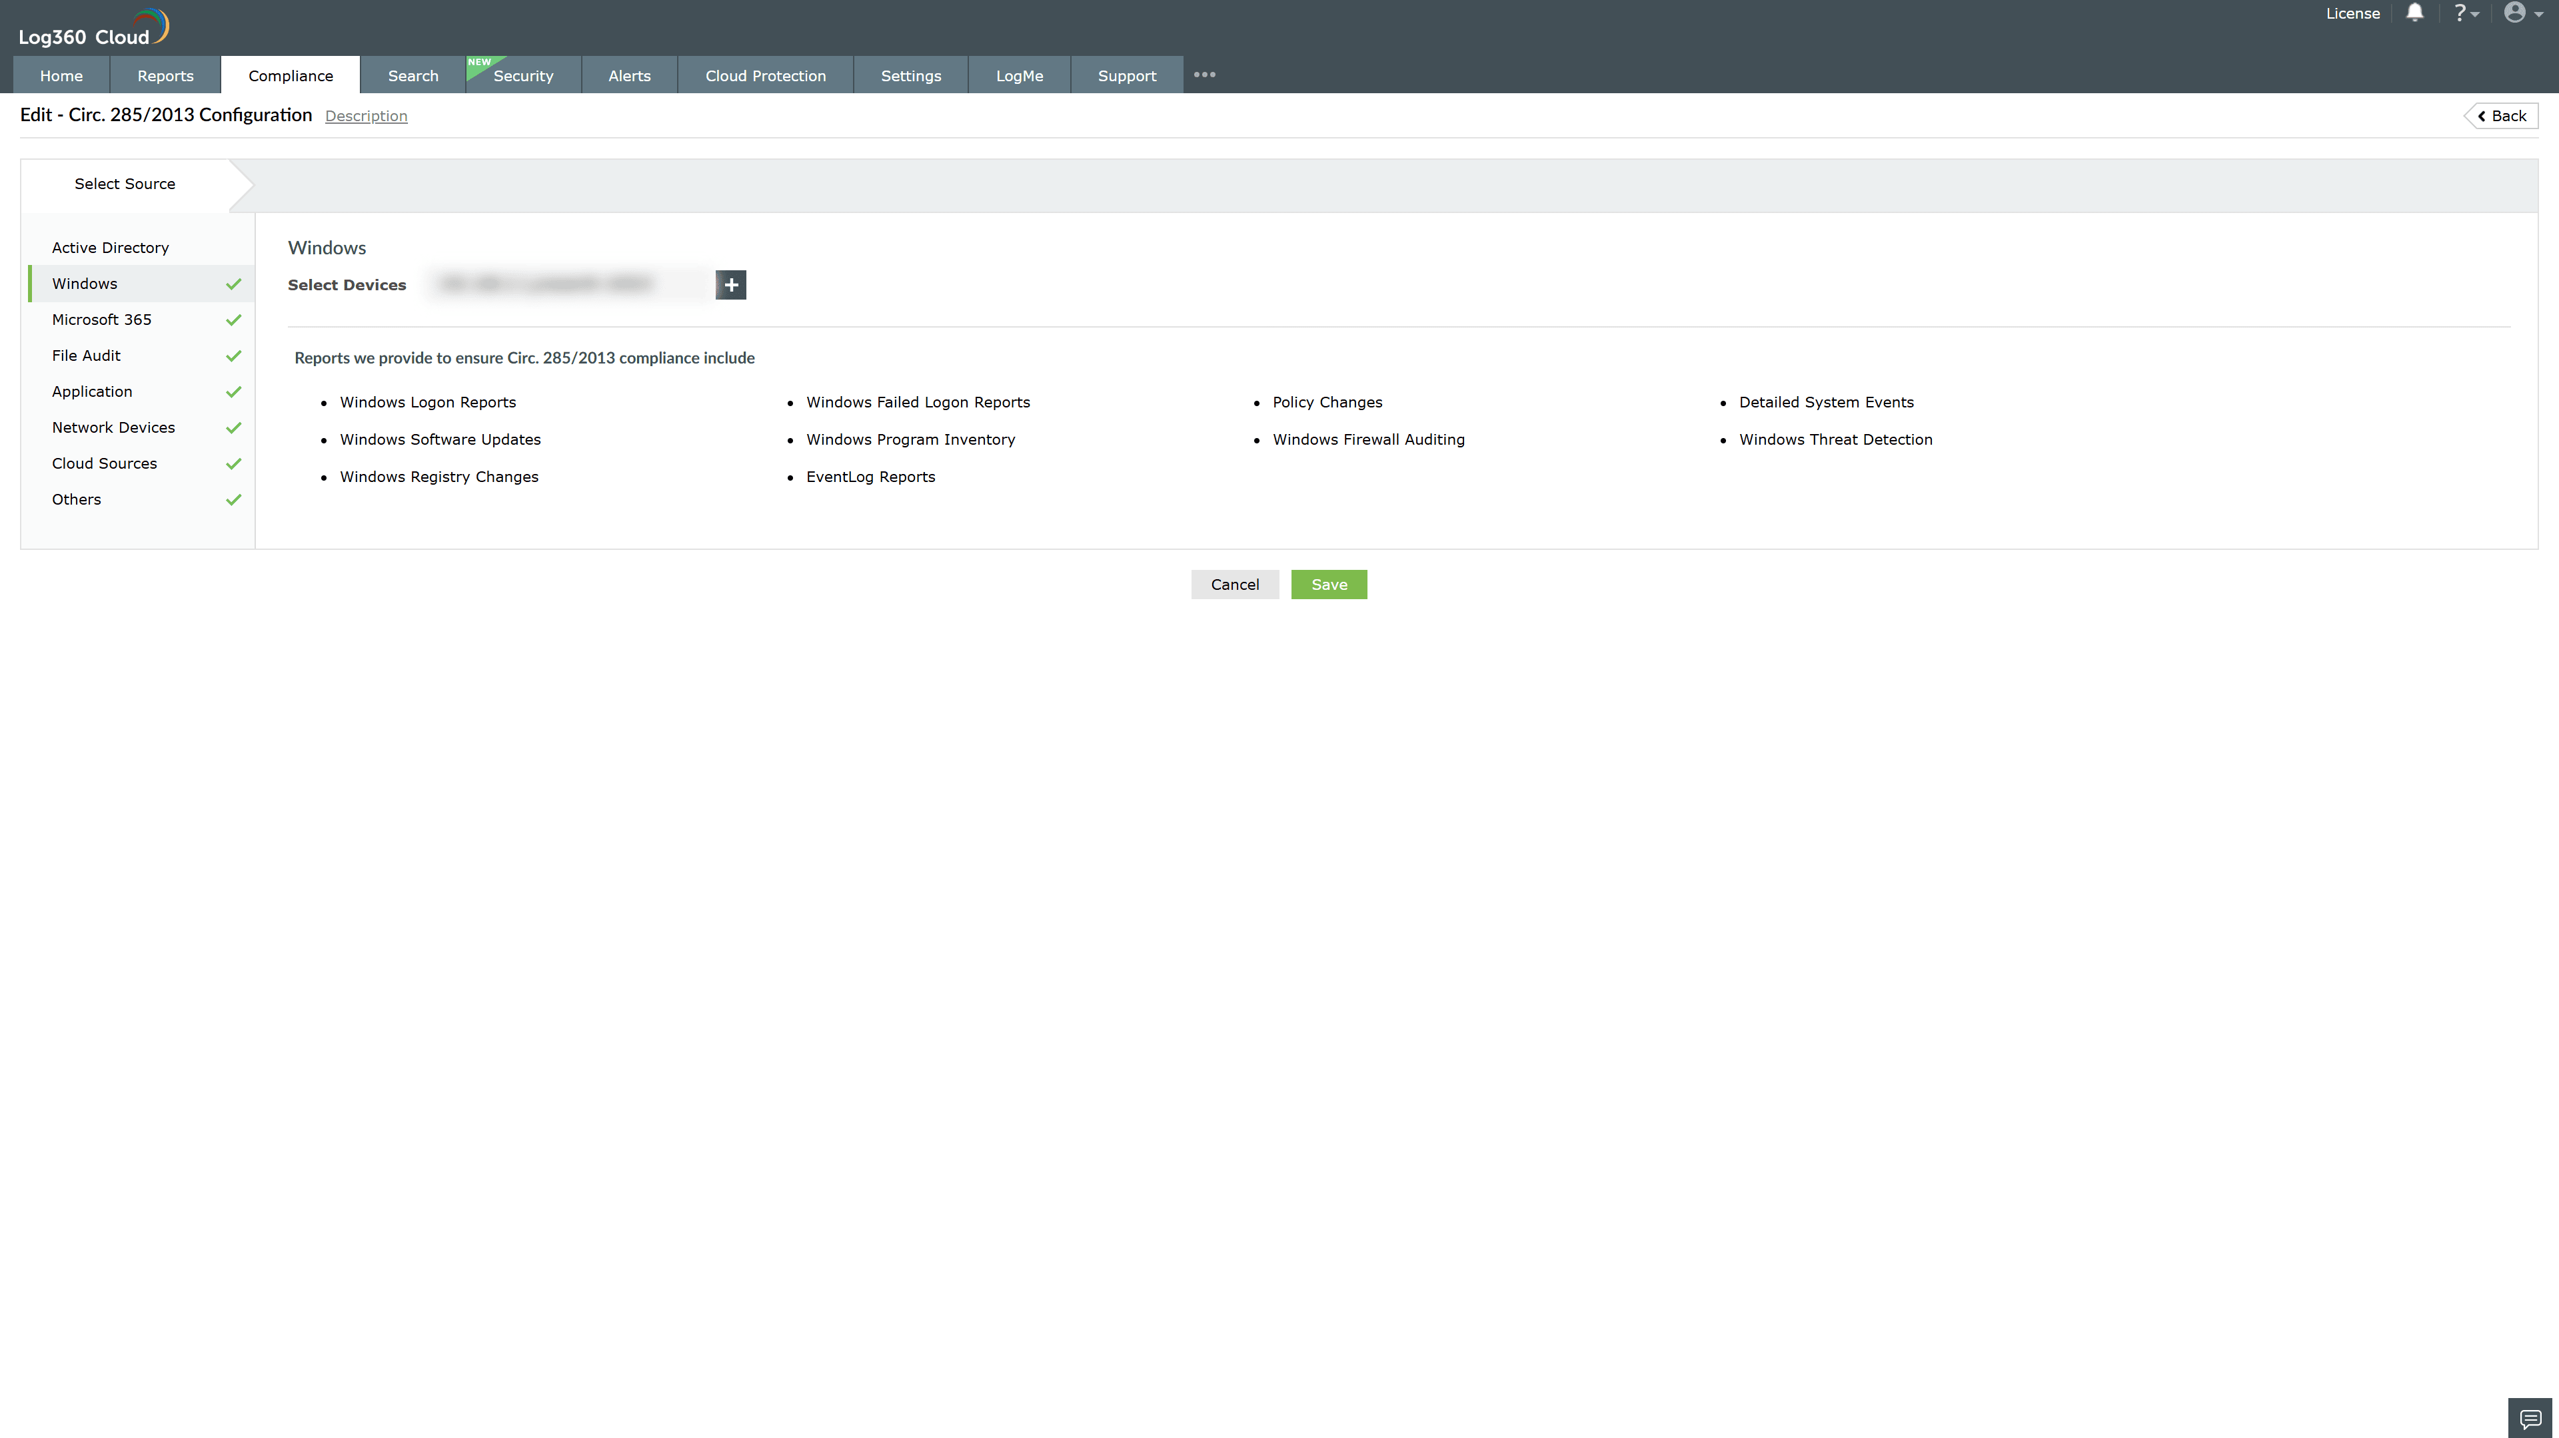

Valid Submission : Yes
Supported Editions : Free, Basic, Standard, Professional, MSSP
Help Document : https://www.manageengine.com/log-management/help/integrations/compliance-extensions.html
Help Video : Not provided
Tags : Log360, Compliance, Privacy monitoring, Data privacy, Regulatory compliance
Supported DCs : US, IN, JP, CA, AU, UK and EU
Privacy Policy:
Terms of Service:
Release Notes:
Predefined reports for the Banca d'Italia Circular 285/2013 Compliance

